StudentVUE Directions for Course Registration
Please follow these step-by-step directions to enter your Course Requests for the 2024-2025 school year at Raymond S. Kellis High School.

- Log in to your student portal and open StudentVUE from the menu bar at the top.

- Click “Click to Enter”


- Click “I am a Student” and enter your log in information.

- Choose the tab from the left side called “Course Request”
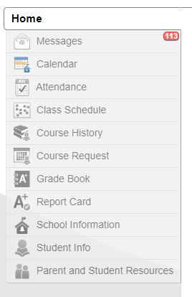

- Click “Click here to change course requests”
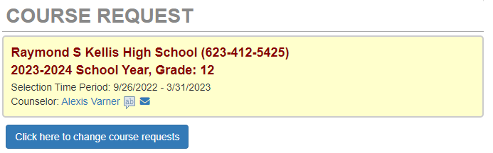

- Selected Course Requests will show on your screen. Notice that some of your courses have been pre-populated for you. You will ONLY remove them if you are taking a different level course (i.e. you want Honors/AP).

- Search for your requested course by Course Name or Course Number. These can be found on the Elective Sheet. 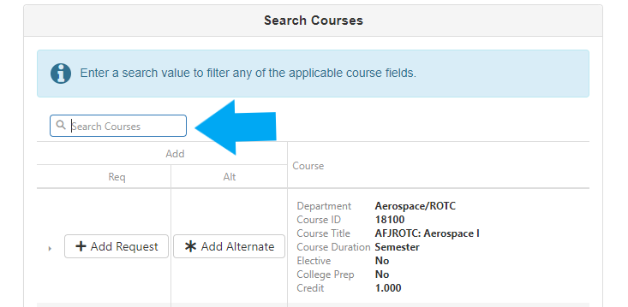

- When the course appears, you may click “Add Request” for class to be requested in your 8 Main Classes. OR…”Add Alternate” for the class to be requested as an alternate course.
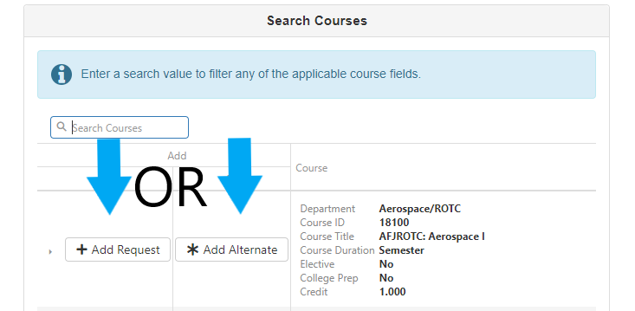

- Repeat process until you have 8 Main Classes requested AND 3 Alternate Classes requested.

Congratulations! You have requested your courses for the 2024-2025 school year!

